HopCroft Forum

16th January 2017

Re: Draft Neighbourhood Plan

Dear Sir/Madam,

In connection with your plan for a “neighbourhood” including parts of Honor Oak, the Friends of Honor Oak have some serious concerns with the approach being taken.

The key issue would seem to be a neighbourhood boundary which cuts through the middle of the Honor Oak community. Splitting the neighbourhood in this way pushes areas to the margins of the “neighbourhood area” which are actually central to the community of Honor Oak.

Of particular concern is the proposal for housing development adjacent to Honor Oak Park station (SA2). We see a number of problems with this:

- The area in question was re-profiled by Network Rail in 2010 to protect the railway infrastructure from land slippage caused by illegal dumping by Southwark Council. This resulted in the loss of many mature trees. Network Rail replanted the embankment with grass and wildflower seed but the stated intention was to let nature return including trees.
- The tree lined embankment created a very pleasant environment from street and platform level, both visually and aurally through the songbirds present. This is much missed by the community and so the area’s proper place relates to its environmental impact rather than a housing contribution. It is also a key feature of the area as recognised in the plan: “natural heritage features include … habitats of nature conservation interest along the railway embankments” (2.7).
- The land is designated as a Site of Importance for Nature Conservation but it is not ecologically sound to view it in isolation (4.5.4 SA2 Policy Justification). The site is part of a green corridor, the Forest Hill to New Cross Grate railway cutting, and this is recognised as of Borough-wide significance by Lewisham Council. It is also a part of contiguous green space that includes the Metropolitan Open Land of Camberwell New Cemetery and One Tree Hill including its Local Nature Reserve. Any ecological survey should be about the wider area, as determined by biogeographical principles including the species-area relationship.
- Any ecological survey, or site assessment, should furthermore be about the area’s former significance as it should be had it not been bulldozed. Any plan that made a positive contribution to the area would recognise this and seek to make good.
- As the area already has a SINC designation, this is the default position and no further study is required for this. Saying that, if development is permitted, that this should not be seen as a precedent is a purely subjective viewpoint. Any other developments proposed for local SINC sites can clearly see it as a precedent to assist an application (4.5.4). This impression is further reinforced by the lack of policy protection for green sites within the neighbourhood area, e.g. Garthorne Road Nature Reserve.
- The local area is classed by Lewisham Council as a low development area. There are good reasons for this. Of particular note is that any development on this site would not fall within the catchment area of any local primary schools. The infrastructure is already struggling to cope with the housing present. Requiring development to contribute to social infrastructure does not mean that any provision will be forthcoming locally unless this is specifically provided for – no mention is made in the plan of any such specific infrastructure provision.
- If school provision is to rely on developer community infrastructure levy then, unless there is a policy to increase this levy above the value required to support the specific development, then there would still be a deficit as there is one before any development was started. As a result, there would be no reasonable prospect of getting schools coverage.
- The plan seeks to encourage large development which would inevitably be flats. 10 or more dwellings are planned in the site allocations (4.5.1) and this could only be achieved that way on this site. It would be out of keeping in the character of the area which is mostly period housing. A distinction can be made with developments alongside Brockley station (west side) and Forest Hill station both of which replaced previously industrial areas. No such industrial areas exist in this area and no similar developments exist to allow such a development to be ‘in keeping’ with the local environment. The proposal for any development is fundamentally inconsistent with the environmental aims.
- Figure 4: Location of Community Assets (p31), indicates a “key view” in the direction of One Tree Hill. This is inconsistent with development on this site which would destroy such a view.
- The view from Honor Oak Park station, on arrival, is probably the dominant gateway view on arrival in the area by actual arrival counted. To spoil this with a block of flats, or other inappropriate development, would be detrimental to the area and go against policies (4.11.2 & Project 10) which seek to enhance gateways into the area.
- Housing development is probably not a good idea here due to subsidence and drainage management issues. This could be further impacted by drainage runoff as a consequence of any new burial development in Camberwell New Cemetery so Southwark Council should be consulted.
- Any access to this site would have to be via Honor Oak Park and intersects with the busy zebra crossing present and neighbouring junction with Devonshire Road. As per Highway Code, this is zigzagged and access here would not be safe.
- Allocating this site, along with SA1, as “allocated for residential development” already (4.5.2) is procedurally improper given that the site has SINC status. This prejudices the outcome of ecological surveys (4.5.2) and is inconsistent with the Site Assessment which states “This site is not suitable for development due to its designation as a Site of Nature Conservation Interest” (p35, Site Assessment).
- Alternative site allocations would be much more appropriate, e.g. green walk like Devonshire Road Nature Reserve, linkage with Green Chain, pedestrian market area in a green setting or woodland/meadow enhancements. If done sensitively, this would be consistent with the aim to “improve access to natural habitats along railway embankments” (2.7).

If alternative housing allocation is sought, a comparable area could be allocated from the northern tip of the Garthorne Road Nature Reserve. This would have the advantage, from a development perspective, of being already adjacent to existing utilities and road access from Grierson Road. We do not consider development on this site to be desirable either but it is a useful and more straightforward comparison that we note has not been brought forward.

It is also not clear why the site at Sevenoaks Road, opposite the Brockley Jack, does not count towards housing allocation as presumably this will be part of any development allowed on this site.

Some other comments:

- Already a large proportion of dwellings are houses converted to flats, e.g. Of the 717 homes on Devonshire Road, 600 are flats (including apartments and maisonettes), so the stated intention of provision for family housing (4.5.1) will be further reduced instead if there is a policy to encourage even more houses to be converted to flats.
- Honor Oak Park parade has already been detrimentally impacted through the historic conversion of commercial units to residential. A policy to change shops into flats is not appropriate here (4.5.1) and, in any case, this contradicts an intention to preserve shops (2.5).
- The Gateway enhancement project makes no mention of the William Mitchell sculpture to be found on the road bridge on Honor Oak Park. This is adjacent to the “Welcome to Honor Oak Park” sign and visible to visitors by rail, bus and car so would seem to be a key gateway feature.
- It is incorrect to say that we do not have an Air Quality Management area because it has been the subject of a review.

The recent photo on the following page demonstrates the true character of the area and of the proposed site. If any proposal to were to seek to rely on the mandatory clearance of the site, carried out to remedy subsidence, so as to justify an ecological survey that should look to overturn a Site of Importance for Nature Conservation designation, that would clearly be inappropriate. Remedial work would either need to be prohibited at any a Site of Importance for Nature Conservation or the designation could be undermined at any time by such remedial work. By the same token that we would not consider a house undergoing renovation to be derelict simply because it is in a necessary state of change, we refer you to the fairly recent photo below which shows the actual character of Honor Oak Park, as a gateway to the neighbourhood, and urge that you promote its renewal in accordance with the key view that you have classified and the general reference to preservation of the historic character of the area throughout the draft plan.

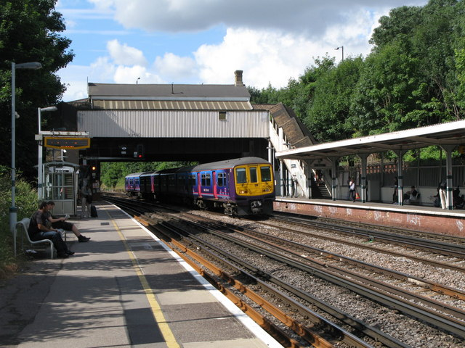

Yours sincerely,

Friends of Honor Oak

http://www.mouseprice.com/property-information/ref-30808730
https://www.lewisham.gov.uk/myservices/environment/air-pollution/Pages/Crofton-Park-and-Honor-Oak-Park-Air-Quality-Management-Area.aspx

