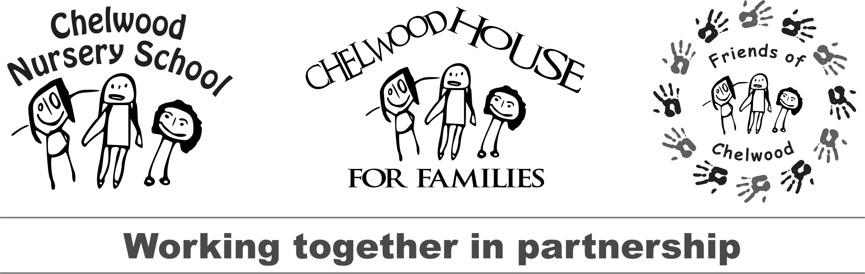
Dear Local Business,

Chelwood Nursery School is a small Lewisham nursery school with a charity, Chelwood House for Families (charity no. 1145048). We work with children and families in the Honor Oak Estate area of Lewisham, and work with children under five years old across the Brockley, Crofton Park, Telegraph Hill, Forest Hill and Honor Oak Park community.

Recent fundraising events have helped to fund a Welcome Group to help families getting to know each other in the local area, Forest School activities for children, parents and toddlers, Family Gardening sessions, developments to our outdoor play spaces.
By working closely with Chelwood Nursery School and the local community, the charity is able to provide a range of services and make a positive impact on the lives of the children and families in our local area.

We regularly hold fundraising events and are hoping that your business might support our charity and our work by providing a donation to our Treat a Friend fundraiser that will take place at our Winter Fair.

Our next event is: Winter Fair on Saturday 24th November 2018

We are asking local cafés, bars, restaurants and take-aways to donate to ‘Treat a Friend’ the idea is for winners of donations pledged to be able to treat a friend spending some quality time at your business. Treat a Friend donations have included:

- Coffee and croissant for two
- Tea and cake for two
- Prosecco for two
- Starters for two
- A cocktail for two
- Bottomless brunch for two
- Free cooked breakfast for two
- Burger and milkshakes for two
- Two Combo breakfasts

Charitable donations from local businesses are advertised at our events, and on our Facebook , Twitter and Instagram pages so our community is aware of the wonderful support we are getting for you!

Making a charitable donation in this way can be beneficial for your business, raising your profile in the local community whilst helping to raise money for a good cause.
There is also Tax Relief available for your business if you make charitable donations. More information about this can be found at:

https://www.gov.uk/tax-limited-company-gives-to-charity

Please consider displaying a poster or making a contribution to our event.

Local businesses who have supported us in recent years include:

Brickfields
The Orchard
Fred’s
Arlo and Moe
Bite Mi
Hilly Fields Cafe
Bella Nova
Brockley Deli
Doorstep Bakery
Mus’s Café Central Café and more…

We look forward to hearing from you and hope you will be interested in supporting our families.
Thank you for your support!
With thanks
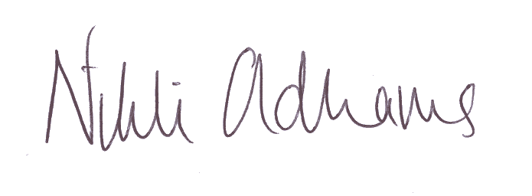

Nikki Oldhams
Headteacher

*******************************************************************
Your Friends of Chelwood contact bringing this letter to you is:

They can be contacted on: Tel - Email:

For further information or queries please email: friends@chelwood.lewisham.sch.uk

and look us up www.chelwood.lewisham.sch.uk
www.chelwoodhouse.org

Follow us on Facebook: @chelwoodnurseryschool @chelwoodhouseforfamilies
Twitter: @ChelwoodHT Instagram: ChelwoodNurserySchool

Business Name:

Pledges the following for two people to enjoy at our business -

description of pledge:

Valid until:

I am authorised to make this pledge on behalf of the business named above:

Signed by:

Print Name:

Position in company:

